Determine whether each of the following statements is true or false.

- [2] Simulated Annealing with a constant, positive temperature at all times is the same as Hill-Climbing.

False because there is always some non-negative probability of moving to a worse state.

- [2] Breadth-First search is a complete algorithm even if all operators do not have the same cost.

True because breadth-first search does not use operator costs, only the depth of a node.

- [2] When Hill-Climbing and Greedy Best-First searches use the same admissible heuristic function, they both expand the same set of nodes in any search space.

False

- [2] If h1 and h2 are both admissible heuristics, then it is always preferable to use the heuristic h3(n) = max(h1(n), h2(n)) over the heuristic h4(n) = min(h1(n), h2(n)).

True

. [ 10] Search: Short Answer Questions

- [2] True or False: The main difference between Simulated Annealing and conventional Hill-Climbing is that Simulated Annealing allows restarts from multiple, random initial states.

False

- [2] True or False: Greedy Best-First search with h(n )=0 for all nodes n is guaranteed to find an optimal solution if all arc costs are 1.

False

- [2] True or False: In afinite search space containing no goal state, Algorithm A will always explore all states.

True

(d) [2] Search using evaluation function f(n) = depth(n) corresponds to which search method? Depth-First search

- [2] True or False: If it is known that all arc costs are greater than or equal to -1 (i.e., both positive and negative real-valued costs are allowed but the cost of an operator cannot be less than the fixed constant -1) and the state space does not contain cycles, uniform-cost search is still guaranteed to find an optimal solution.
False. Consider, | for | example, the state space where s--(3)-->
g, s -- (4) --> n1, | n1 | -- (-1) --> n2, n2 -- (-1) --> n3, n3 -- (-1) -->
n4, n4 --(-1)--> | n5, | n5 --(-1)--> g. UCS finds the non-optimal
solution path s--g, which has cost 3, while the optimal path s--n1--n2--n3--n4--n5--g has cost -1.

[ 14] Heuristic Search
Consider the search space shown below with start state S and goal state G. The values of a heuristic function, h, are shown at each node.
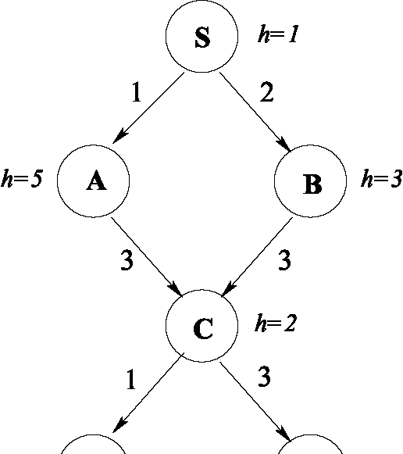
h=0 h=0
D G
Unfortunately, we do not know the cost of the operators that determine the costs associated with each arc in the graph. Fortunately, we do have the following trace of the OPEN list produced during the execution of the A* algorithm. Note: The front of the OPEN list is on the left, and repeated states are removed, keeping only the minimum f value.
1. | {(S,f=1)}
2. | {(B,f=5), | (A,f=6)}
3. | {(A,f=6), | (C,f=7)}
4. | {(C,f=6)}
5. | {(D,f=5), | (G,f=7)}
6. | {(G,f=6)}
Based on this information, compute each of the arc costs and add them to the search graph above. Show your work.

In the A* algorithm, f=g+h, so g=fh. The order of node expansion tells us which edge was followed at each step. At Step 2 h(B)=3, so c(B, S) = 5- 3= 2. Also, h(A) = 5, so C(A, S) = 6- 5= 1. And, g(A) = c(A, S) = 1, and g(B) = c(B, S) = 2.

At Step 3, h(C) = 2, so c(C, B) = f(C-via-B) - g(B) - h(C) = 7- 2
- 2= 3. And, g(C) = c(C,B) + g(B) = 3+ 2 = 5.

At Step 4, h(C) = 2, so c(C, A) = f(C-via-A) - g(A) - h(C) = 6- 1
- 2= 3. And now we update g(C) because we’ve found a cheaper path; g(C) = c(C, A) + g(A) = 3+ 1= 4.

At Step 5, h(D) = 0, so c(D, C) = f(D-via-C) - g(C) - h(D) = 5- 4
- 0= 1. And, g(D) = c(D, C) + g(C) = 1+ 4= 5. Similarly, h(G) = 0, so c(G, C) = f(G-via-C) - g(C) - h(G) = 7- 4- 0= 3. And, g (G) = c (G, C) + g (C) = 3 + 4 = 7 .

At Step 6, h(G) = 0, so c(G, D) = f(G-via-D) - g(D) - h(G) = 6- 5
- 0= 1. And, g(G) = c(G, D) + g(D) = 1+ 5= 6.

3. [ 10] Evaluation Functions for Heuristic Search
CS 540 Midterm Exam Summer 2004
(page 3 of 11)
Say we define the evaluation function for use in a heuristic search problem as
f (n) = (1w)g(n) + wh (n)
where g(n) is the cost of the best path found from the start state to state n, h(n) is an admissible heuristic function that estimates the cost of a path from n to a goal state, and 0.0 w1.0.

- [9] What search algorithm do you get when (i) w = 0.0

Uniform-Cost search

(ii)w=0.5

A* search

(iii) w = 1.0

Greedy Best-First search
- [ 1] Based on your answer to (a), for what range of values of w would you expect your algorithm is admissible?
0 ≤ w≤ 0.5

